SOFTWARE REQUIREMENTS SPECIFICATION

**For**

**Hospital Appointment Scheduler**

**Prepared by:-**

*Akshaya J*

*Dhasana A*

*Harini V*

# Introduction

## Purpose

The health care industry now is one of the largest and most important industries in most countries. It provides individuals access to medical and non-medical services that are aimed at improving that individual's quality of life. In many health care facilities, however, there exists a severe need for improvement in the quality of service and patient waiting times. These needs must be met with an efficient and practical solution. This solution must make use of the hospital’s valuable resources, such as medical expert’s time, in the most efficient manner. Hospitals are continuously fighting a scheduling problem that causes either a waste in medical expert time or a decrease in patient satisfaction and staff morale. Many scheduling systems have been developed and implemented in order to improve such operations in individual hospitals or even groups of health care facilities. This project describes the hardware and software interface requirements using ER diagrams and UML diagrams.

## 1.2Document Conventions

* + - Entire document should be justified.
    - Convention for Main title

Font face: Times New Roman Font style: Bold

Font Size: 14

* + - Convention for Sub title

Font face: Times New Roman Font style: Bold

Font Size: 12

* + - Convention for body

Font face: Times New Roman Font Size: 12

## Scope of Development Project

## Developing a hospital appointment scheduler involves creating a comprehensive system to streamline the management of healthcare appointments. The project's scope includes designing an intuitive user interface with features such as user authentication, patient registration, and appointment scheduling. The system should utilize a robust database to store critical information like patient details, appointment records, and healthcare provider availability. The modular design ensures scalability and maintainability to adapt to evolving healthcare needs.

## To enhance user experience and workflow optimization, the scheduler should incorporate real-time availability updates and automated notifications for both patients and healthcare providers. Features like appointment rescheduling and cancellation functionality contribute to the system's flexibility. Integration with calendar systems can facilitate synchronization and avoid scheduling conflicts. Thorough testing, including unit testing and user acceptance testing, is crucial to ensure reliability and correctness. Adherence to security best practices is paramount to protect sensitive patient data and comply with healthcare privacy regulations.

## 

## The development project should follow established software engineering principles, including documentation and version control, to support future maintenance and updates. Regular updates and feedback mechanisms should be considered to address emerging requirements and ensure the long-term effectiveness of the hospital appointment scheduler. Continuous improvement and adaptability to evolving healthcare practices should be integral aspects of the project's development lifecycle.

## Definitions, Acronyms and Abbreviations

JAVA -> platform independence SQL-> Structured query Language ER-> Entity Relationship

UML -> Unified Modeling Language

IDE-> Integrated Development Environment SRS-> Software Requirement Specification

## 1.5 References

## Books:

## "Healthcare Information Technology Exam Guide for CompTIA Healthcare IT Technician and HIT Pro Certifications" by Kathleen A. McCormick

## "Healthcare Information Technology and Management" by Richard D. Bankowitz, Joseph S. Bove, and Jerald Hage

## "Principles of Health Interoperability HL7 and SNOMED" by Tim Benson

## Websites:

## Healthcare Information and Management Systems Society (HIMSS) - himss.org

## American Medical Association (AMA) - ama-assn.org

## Centers for Medicare & Medicaid Services (CMS) - cms.gov

# Overall Descriptions

## Product Perspective

Use Case Diagram of Hospital Appointment Scheduler

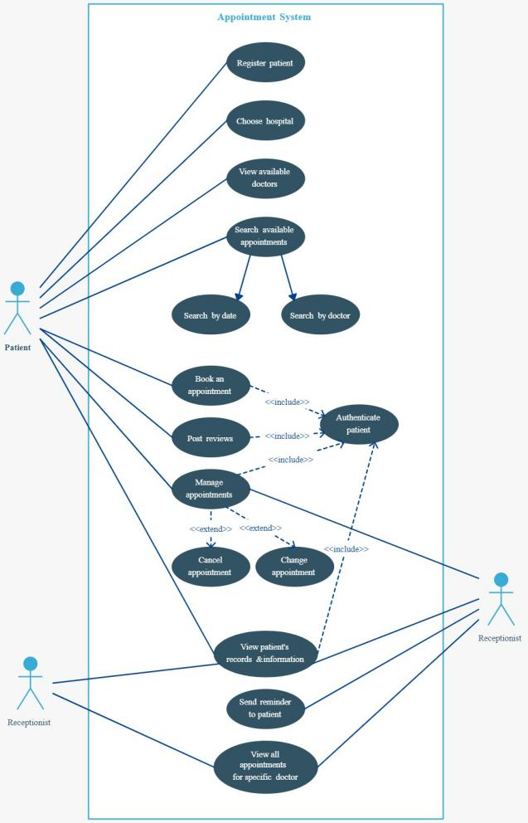

This is a broad level diagram of the project showing a basic overview. The users can be either staff or student.. This System will provide a search functionality to facilitate the search of resources. This search will be based on various categories viz. book name or the ISBN. Further the library staff personnel can add/update the resources and the resource users from the

system.The users of the system can request issue/renew/return of books for which they would have to follow certain criteria.

## Product Function

Entity Relationship Diagram of Library Management System

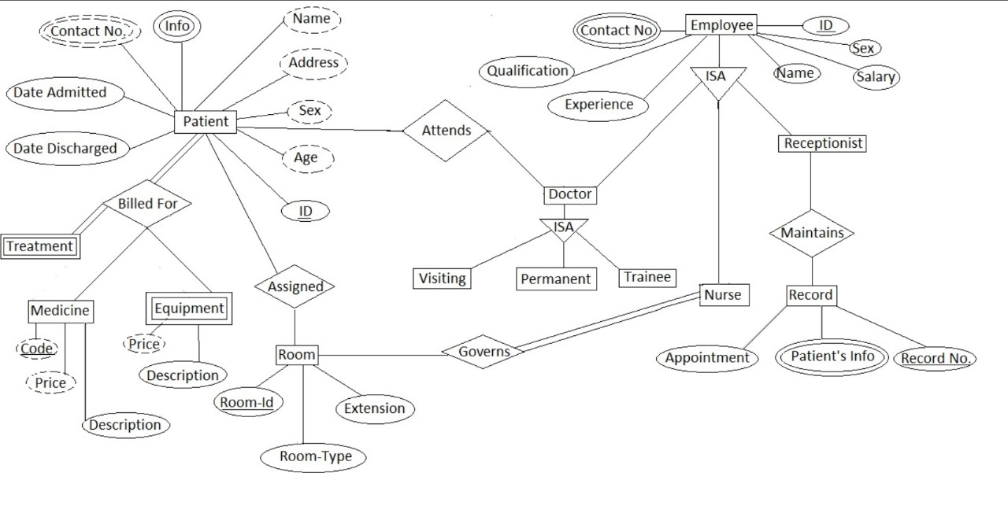

The Hospital Appointment Scheduler operates in real-time, automating and streamlining appointment management to minimize manual efforts. Its core function is to facilitate efficient scheduling, modifications, and cancellations of patient appointments. Serving as a central administration tool, healthcare staff oversee and control the scheduling process, ensuring smooth coordination between patients and healthcare providers. Patients with authorized access can easily view and manage their appointment details. The system maintains up-to-date records, enabling swift retrieval of patient information by healthcare providers from the database. This precision enhances the appointment scheduling process, optimizing operational efficiency within the healthcare facility.